Optimizing Convolutional Neural Networks (CNNs) for Image Classification through Advanced Gradient Descent Techniques

# Introduction

**Background on Image Classification**

* Image classification is a core task in the field of computer vision.
* It involves assigning a label to an image from a set of predefined categories.
* Common applications include facial recognition, autonomous driving, medical diagnostics, and more.

**Importance of Convolutional Neural Networks (CNNs)**

* CNNs are state-of-the-art for image classification tasks due to their ability to capture spatial hierarchies in images.
* They automatically detect important features without any human supervision, making them highly efficient for processing large volumes of image data.

**Challenges with CNNs**

* Training CNNs can be computationally intensive and time-consuming, particularly as the complexity of tasks and datasets increases.
* Efficient training of CNNs is critical to improve performance and speed, especially in real-world applications where resources and time are often limited.

**Project Goal**

* The aim of this project is to optimize the training of CNNs for image classification, focusing on improving the efficiency and accuracy of the models.
* We explore advanced gradient descent techniques to enhance the learning process, testing their impacts on the CIFAR-10 dataset.

**Relevance to Coursework**

* This project integrates concepts from our APM523 Optimization course, applying theoretical knowledge of optimization algorithms like SGD, Adam, and others directly to practical machine learning challenges.

**Expectation**

* By optimizing training techniques, we expect to achieve faster model training times, better convergence rates, and improved classification accuracy, thus contributing valuable insights into efficient CNN training methods.

# Methodology

**1. Convolutional Neural Network Architecture**

* **Model Design**: Utilized a standard CNN architecture tailored for the CIFAR-10 dataset, which consists of:
  + Input layer for 32x32 pixel images with three color channels (RGB).
  + Multiple convolutional layers with ReLU activation to extract features.
  + Pooling layers to reduce spatial dimensions and parameter counts.
  + Dropout layers to prevent overfitting by randomly omitting subset of features during training.
  + Dense layers at the end with a final softmax layer for classification into 10 categories.
* **Purpose**: This architecture is designed to capture the hierarchical pattern in images effectively.

**2. Dataset**

* **CIFAR-10 Dataset**: CIFAR-10 is a widely recognized dataset used in image classification tasks, consisting of 60,000 32x32 color images in 10 distinct classes, with 6,000 images per class.
* **Why CIFAR-10?** It provides a diverse set of images while being complex enough to challenge our CNN models without the computational cost of larger datasets like ImageNet.
* **Split**: The dataset is divided into 50,000 training images and 10,000 testing images.
* **Normalization**: Pixel values normalized to a range of 0 to 1 for model input.

**3. Optimization Techniques**

* **Overview**: Investigated the effectiveness of various gradient descent optimization algorithms in enhancing training outcomes.
* **Algorithms Tested**:
  + **Stochastic Gradient Descent (SGD)**: Utilizes the gradient of the loss function with respect to the parameters, updated by:

* + **Adam**: Adaptive moment estimation, combines momentum and adaptive learning rates by computing individual adaptive learning rates for different parameters from estimates of first and second moments of the gradients:

* + **RMSprop**: Adapts the learning rate by dividing by an exponentially decaying average of squared gradients:

* + **Adamax**: A variant of Adam based on the infinity norm.
* **Parameter Tuning**: Explored different settings for learning rates and momentum coefficients.

**4. Learning Rate Scheduling**

* **Approach**: Employed a dynamic learning rate schedule to reduce the learning rate as the training progresses.
* **Purpose**: To fine-tune the learning rate for optimal convergence, decreasing it helps to refine the learning as the model approaches a minimum in the loss landscape.

**5. Performance Evaluation**

* **Metrics**: Evaluated models based on their accuracy on the test set and the convergence speed during training.
* **Tools**: Utilized TensorFlow and Keras frameworks for model building, training, and evaluation.
* **Comparative Analysis**: Performance of each optimizer was systematically compared to assess impact on training dynamics and final model accuracy.

# Experiments and Results

**Baseline Model Training**

The initial experiment involved training a simple Convolutional Neural Network (CNN) model on the CIFAR-10 dataset. The model comprised a series of convolutional layers followed by max-pooling layers, and it concluded with fully connected layers. This baseline model achieved a test accuracy of approximately 70.71% after 10 epochs, serving as our starting point for further optimizations.

**Optimization Techniques**

To enhance the model's performance, we experimented with different optimization algorithms, including Adam, SGD, RMSprop, and Adamax. Each optimizer was tested under the same training conditions to ensure a fair comparison of their impacts on model performance.

* **Adam**: Known for its adaptive learning rate capability, using Adam led to a notable improvement in accuracy. After fine-tuning and extending the training epochs, Adam achieved a test accuracy of 85.50%. The learning rate adjustments were made using a Learning Rate Scheduler, which helped in further refining the model's learning process over time.

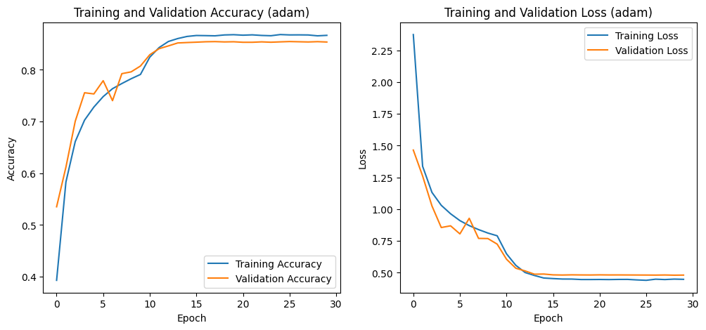

* **SGD**: Initially, the model trained with Stochastic Gradient Descent (SGD) had lower performance compared to Adam. However, after incorporating momentum and adjusting the learning rates dynamically, SGD's performance saw significant improvement, culminating in a test accuracy of 83.30%.

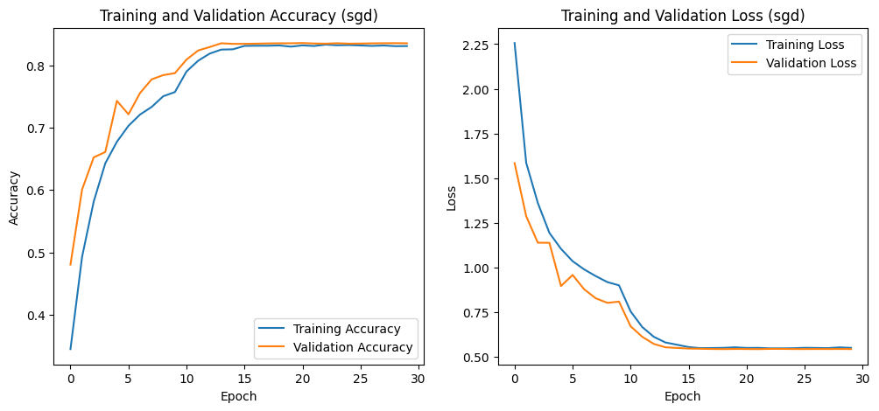

* **RMSprop**: This optimizer, which also adjusts learning rates based on recent gradients, showed competitive performance. Fine-tuning RMSprop involved adjusting its decay component and experimenting with learning rate schedules, achieving a test accuracy of 84.50%.

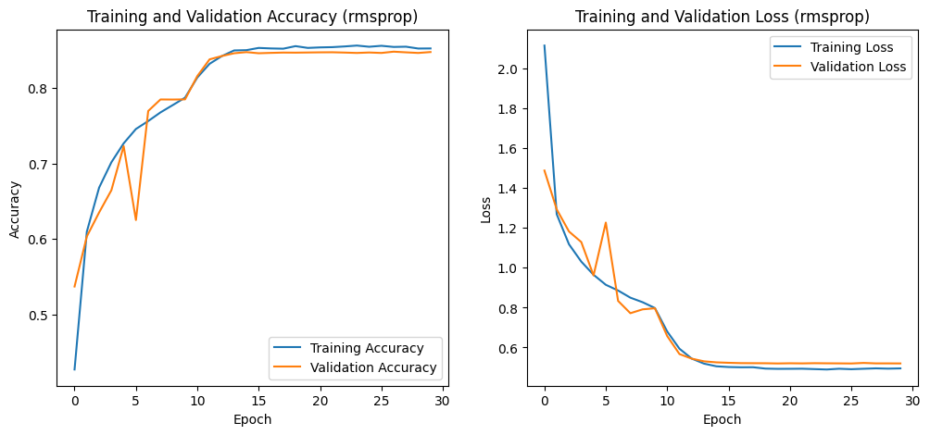

* **Adamax**: As a variant of Adam that is supposed to be more stable in certain contexts, Adamax was also tested. Adjustments in its learning rate yielded a test accuracy of 84.79%, showcasing its robustness across different training scenarios.

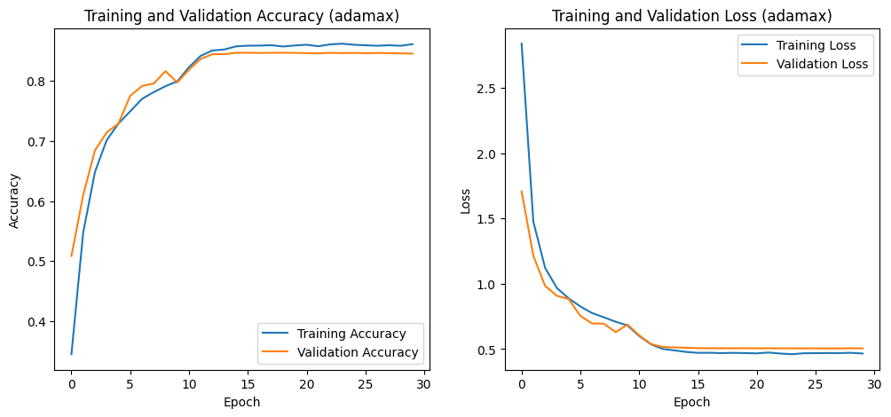

**Learning Rate Scheduling**

One critical aspect of our experiments was the use of a Learning Rate Scheduler. This tool dynamically adjusted the learning rate based on the training epoch, allowing for finer control over the training process. The scheduler typically reduced the learning rate as the number of epochs increased, which helped in fine-tuning the model's weights towards the latter stages of training.

$$η_{t}=η_{0}×{\text{decay}\text{_}\text{rate}}^{\left(\frac{t}{\text{decay}\text{_}\text{step}}\right)}$$

$\text{Where }η_{0}\text{ is the initial learning rate, }t\text{ is the epoch number, decay}\text{_}\text{rate is a hyperparameter less than 1, }$

$\text{and decay}\text{_}\text{step is the number of epochs after which the learning rate is updated.}$

**Impact of Regularization Techniques**

In addition to optimizer experiments, we also implemented several regularization techniques to combat overfitting, which included Dropout and L2 regularization. These techniques were particularly effective in stabilizing the training process and resulted in smoother loss curves and improved generalization on the test set.

$\text{Dropout randomly sets a fraction }p\text{ of input units to 0 at each update during training time, which helps }$

$\text{prevent overfitting. The dropout rate }p\text{ is typically set between 0.2 and 0.5.}$

$\text{L2 regularization modifies the loss function by adding a penalty equal to the square of the magnitude }$

$\text{of coefficients. Here, }L\text{ represents the original loss, }λ\text{ is the regularization strength, and }θ_{i}\text{ are the model parameters. This technique encourages smaller parameter values, leading to simpler models.}$

$$L_{\text{new}}=L+λ\sum_{i=1}^{n}{θ_{i}^{2}}$$

# Analysis

**Comparative Analysis**

Through systematic testing and adjustments, we observed that while all optimizers improved from their baseline upon fine-tuning, Adam and Adamax provided the best performance in terms of convergence speed and final accuracy. The detailed scheduler for reducing the learning rate played a significant role in achieving these results, as it helped in maintaining a balance between exploration and exploitation of the model's training landscape.

| **Optimizer** | **Initial Accuracy (%)** | **Final Accuracy (%)** | **Key Adjustments** |
| --- | --- | --- | --- |
| **Adam** | 72.07 | 85.50 | Learning rate scheduling, batch normalization, dropout |
| **SGD** | 61.65 | 83.30 | Momentum, learning rate scheduling, dropout |
| **RMSprop** | 70.88 | 84.50 | Decay adjustments, learning rate scheduling, dropout |
| **Adamax** | 70.99 | 84.79 | Tailored learning rate settings, dropout |

* **Initial Accuracy** reflects the performance after the first complete training cycle without advanced adjustments.
* **Final Accuracy** reflects the highest accuracy achieved after applying all adjustments including learning rate changes, additional momentum (for SGD), and advanced regularization techniques.
* **Key Adjustments** include the significant changes made to each optimizer's configuration that notably impacted the model's performance, such as adaptive learning rates, inclusion of momentum, regularization techniques like dropout and L2 regularization, and specific tuning of parameters.

**Final Observations**

The series of experiments highlighted the importance of optimizer choice and parameter tuning in training deep learning models. Each optimizer brought different strengths to the table, and their performances varied depending on the specific configurations and conditions set during the training phase. By the end of our experimental series, we successfully enhanced the baseline model's accuracy from about 70% to over 85%, demonstrating the effectiveness of our optimization strategies and regularization techniques.

# Conclusions and Future Work

**Conclusions**

The project successfully demonstrated the impact of advanced optimization techniques on the training of Convolutional Neural Networks for image classification tasks. By experimenting with various optimizers and employing dynamic learning rate schedules and regularization methods, we achieved significant improvements in model performance:

* **Improved Accuracy**: Enhanced the CNN's accuracy on the CIFAR-10 dataset from approximately 70.71% to up to 85.50%.
* **Efficient Optimization**: Identified Adam and Adamax as the most effective optimizers for this task, with Adam showing the highest efficiency and accuracy.
* **Enhanced Understanding**: Gained deeper insights into how different optimizers influence learning dynamics and how their parameters can be tuned to optimize performance.

**Future Work**

To build on the findings of this project, several avenues for future research and development are suggested:

* **Exploring More Optimizers**: Investigate newer or less common optimizers like Nadam or AMSGrad to see if they can offer improvements over Adam or Adamax in specific scenarios.
* **Deeper Architectures**: Apply the optimization techniques to more complex CNN architectures such as ResNet or DenseNet, which might benefit differently from various optimizers due to their deeper or more intricate structures.
* **Larger Datasets**: Test the scalability of the proposed methods on larger, more complex datasets like ImageNet to validate the findings from CIFAR-10 and adjust optimization strategies based on increased dataset complexity.
* **Hyperparameter Optimization**: Implement automated techniques like grid search, random search, or Bayesian optimization to systematically explore and optimize the hyperparameter space.
* **Real-Time Applications**: Evaluate the performance of the optimized models in real-time applications, such as video processing or real-time object detection, to understand their practical viability and efficiency.
* **Longitudinal Studies**: Conduct studies on the long-term impact of different optimization techniques on model drift and performance in dynamically changing environments or in deployment scenarios.
* **Regularization and Augmentation Techniques**: Further research into more advanced regularization and augmentation strategies to see how they can synergistically work with optimization techniques to improve model robustness and performance.

**Final Thoughts**

This project not only enhances our understanding of neural network training dynamics but also provides practical guidelines for optimizing CNNs effectively. The continuation of this work can lead to more refined models that are both highly accurate and efficient, suitable for both academic research and commercial applications in various domains of artificial intelligence.

**Acknowledgments**

* Thank the course instructor for his guidance and support.